附件3
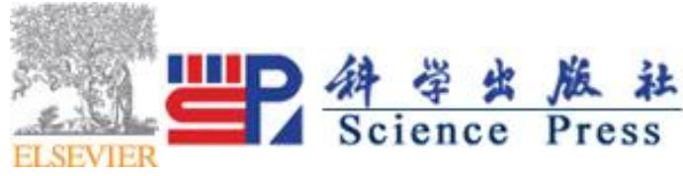
Dear Colleagues

My open access journal, the Geohazard Mechanics is accepting submissions and the published papers will be immediately placed in Elsevier ScienceDirect platform and available to be download for free.
Open Access
Peer Reviewed
No Publication Charge

I sincerely invite you to contribute a paper to this new open access journal，with the relevant topics
of geological hazard and disasters.If conventient，please send the manuscript to email
geohazardmechanics@163.com
Affiliation
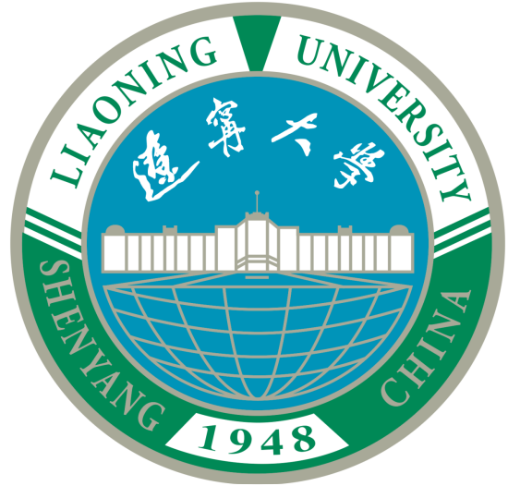
The journal is fully sponsored by Liaoning University,
China, so authors do not need to pay article processing charge.

What the journal is about
Geohazard Mechanics is an international Open Access journal primarily
focusing on the latest research achievements related to rock mechanics in geological disasters such
as rock burst，gas outburst，water inrush，mining-induced earthquakes，mud inrush landslides，
landslides and earthquake etc..It is sponsored by Liaoning University China and published by
KeAi, a joint adventure between Elsevier and China Science Publishing & Media.

Geohazard Mechanics aims to promote international academic exchanges and promote the
development of disaster rock mechanics theory and engineering application.

Submit your paper to Geohazard Mechanics and you'll ensure that your work is freely available
online and accessible to a global readership.

Publish your next open access article free of charge

Most Open Access journals request an article processing charge (APC) for each manuscript
accepted after peer review. The APC is essential to ensure that the journal remains free of
charge for readers everywhere. All publication costs for articles in the Geohazard Mechanics are kindly sponsored by Liaoning University, China, so you as an author do not need to pay an article processing charge.

I am looking forward to reading your work!
Kind regards,
Yishan Pan
Editor-in-Chief of Geohazard Mechanics
地质灾害力学杂志是由辽宁大学主办，科爱公司（科学出版社与爱思维尔集团合资公司）出版的英文 科技期刊。录用的论文通过国际知名全文数据库 ScienceDirect 即时在线发布，面向全球开放获取。期刊不收取作者任何费用。
热忱欢迎国内外学者投稿！

